Conference Article
Write Your Paper Title
Name Surname^{1*}, Name Surname²
¹ Affiliation 1, Orcid ID: https://orcid.org/xxxx-xxxx-xxxx-xxxx, E-mail: xxxxxx@xxx
² Affiliation 2, Orcid ID: https://orcid.org/xxxx-xxxx-xxxx-xxxx, E-mail: xxxxxx@xxx
* Correspondence: e-mail@e-mail.com; Tel.: (optional; include country code)

Received 12 December 2023
Received in revised form 16 January 2024
Accepted 15 February 2024

4th International Conference on Access to Recent Advances in Engineering and Digitalization
May 27 - 28, 2024
Reference: will be edited by editorial
Abstract
Xxxxxxxxxxxxxxxxxxxxxxxxxxxxxxxxxxxxxxxxxxxxxxxxxxxxxxxxxxxxxxxxxxxxxxxxxxxxxxxxxxxxxxxxxxxxxxxxxxxxxxxxxxxxxxxxxxxxxxxx.xxxxxxxxxxxxxxxxxxxxxxxxxxxxxxxxxxxxxxxxxxxxxx.
Keywords: Seamless denim, ultrasonic sewing, hot air bonding, hot press bonding
- Introduction
Xxxxxxxxxxxxxxxxxxxxxxxxxxxxxxxxxxxxxxxxxxxxxxxxxxxxxxxxxxxxxxxxxxxxxxxxxxxxxxxxxxxxxxxxxxxxxxxxxxxxxxxxxxxxxx [1].
- Materials and Methods
Xxxxxxx.
Table 1: Trial Data
Variables | Levels
Fabric composition | 96% cotton - 3% polyester - 1% elastane
Chemical | A, B
Xxxxxxxxxxxxxxxxxxxxxxxxxxxxxxxxxxxxxxxxxxxxxxxxxxxxxxxxxxxxxxxxxxxxxxxxxxxxxxxxxxxxxxxxxxxxxxxxxxxxxxxxxxxxxxxxxxxxxxxxxxxxxxxxxxxxxxxxxxxxxxxxxxxxxx
xxxxxxxxxxxxxxxxxxxxxxxxxxxxxxxxxxxxxxxxxxxxxxxxxxxxxxxxxxxxxxxxxxxxxxxxxxxxxxxxxxxxxxxxxxxxxxxxxxxxx.
  - Subtitle
Xxxxxxxxxxxxxxxxxxxxxxxxxxxxxxx.

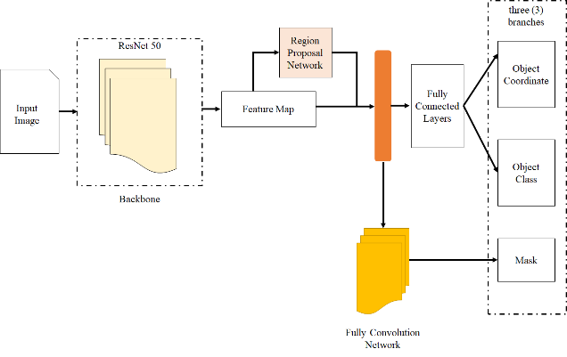
Figure 1: Seamless Denim Product
- Result
Xxxxxxxxxxxxxxxxxxxxxxxxxxxxxxxxxxxxxxxxxxxxxxxxxxxxxxxxxxxxxxxxxxxxxxxxxxxxxxxxxxxxxxxxxxxxxxxxxxxxxxxxxxxxxxxxxxxxxxxxxxxxxxxxxxxxxxxxxxxxxxxxxxxxxxxxxxxxxxxxxxxxxx.
- Discussion and Conclusion
Xxxxxxxxxxxxxxxxxxxxxxxxxxxxxxxxxxxxxxxxxxxxxxxxxxxxxxxxxxxxxxxxxxxxxxxxxxxxxxxxxxxxxxxxxxxxxxxxxxxx.
- Acknowledge
Xxxxxxxxxxxxxxxxxxxxxxxxx.
References
- IEEE Style must use
- Xxxxxxxx.
- Xxxxxxxxxxxx.

